**Version 0**

Lior Pevzner 206215543

Mark Oulitin 208283291

Tom Sandalon 313173718

Tomer Nagar 312178874

Netanel Yehuda 203247978

**Architecture diagram:**

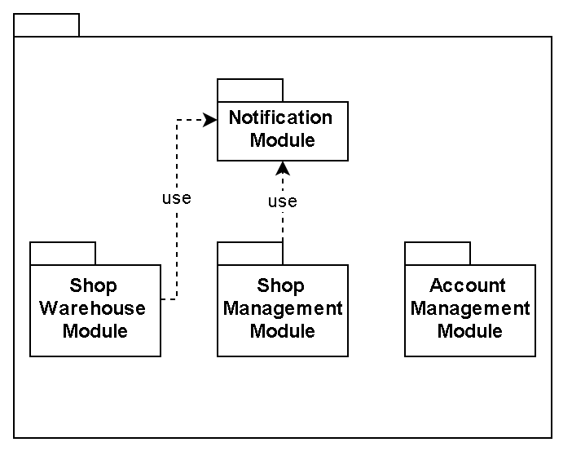

**White Class Diagram:**

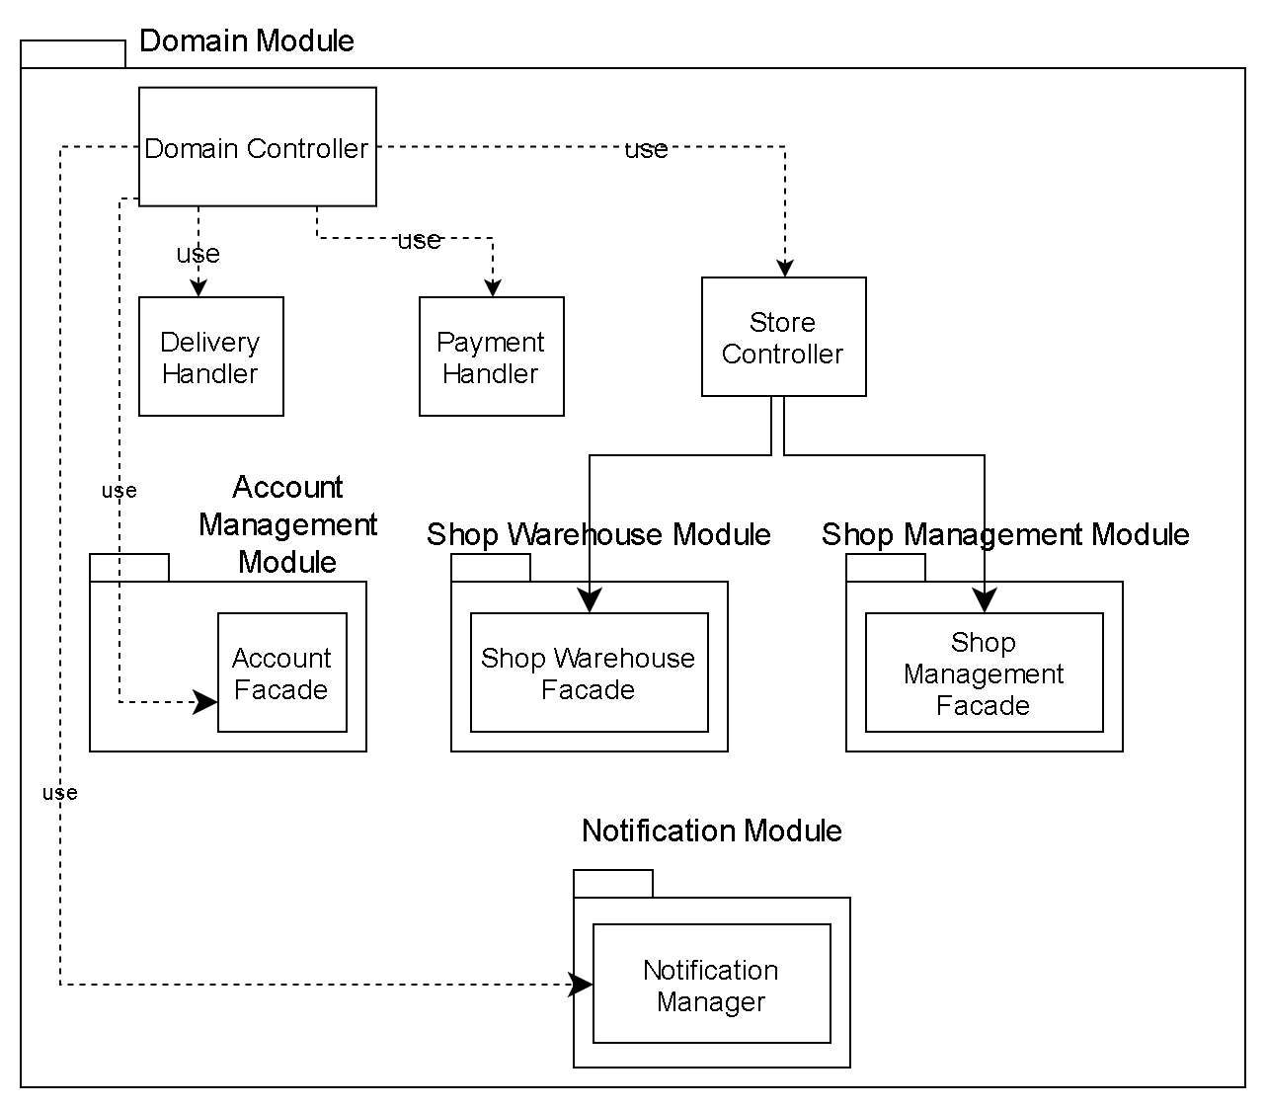

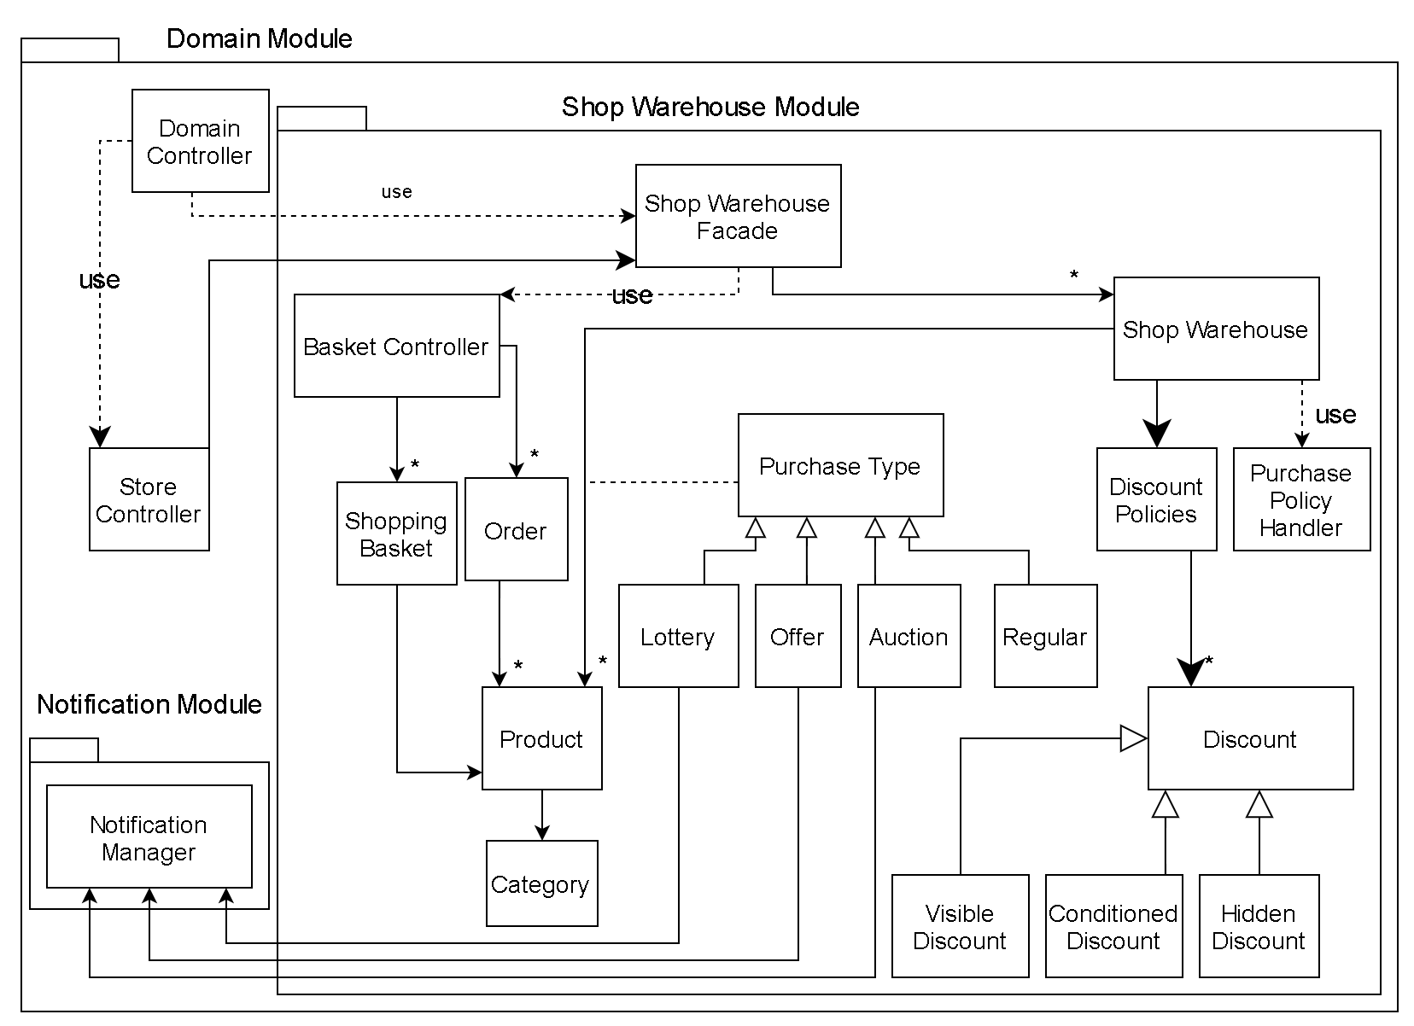

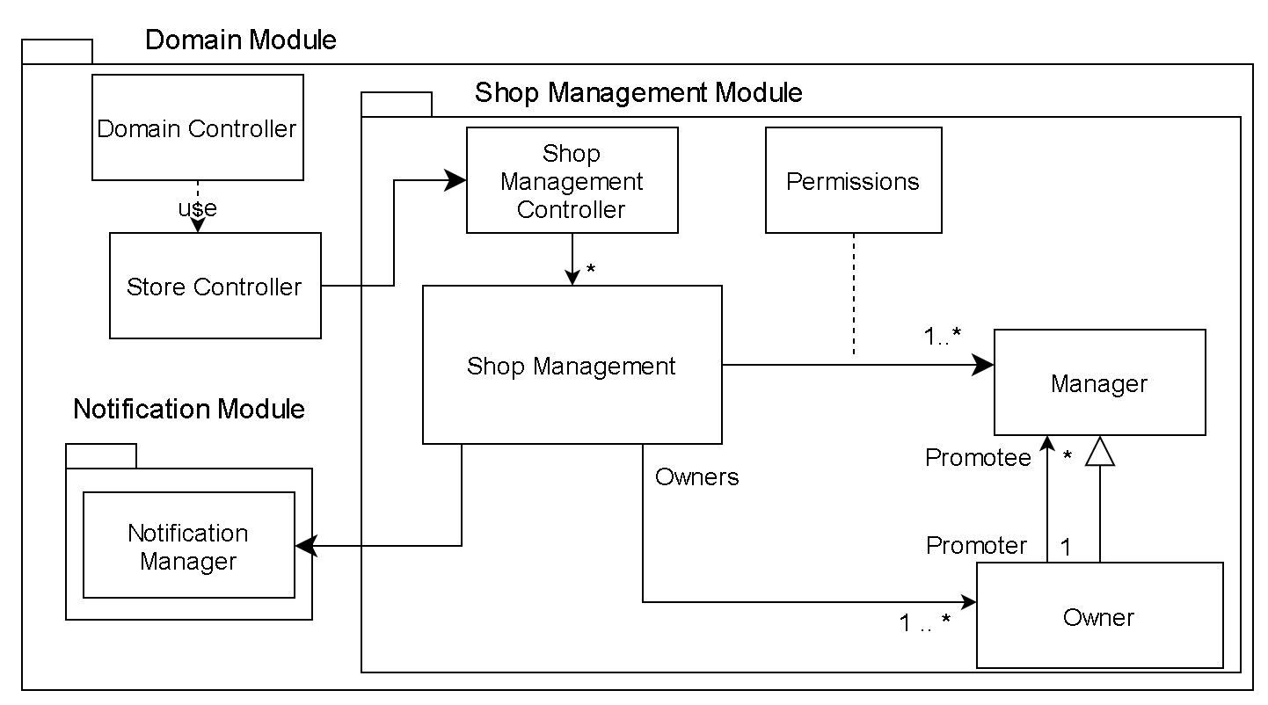

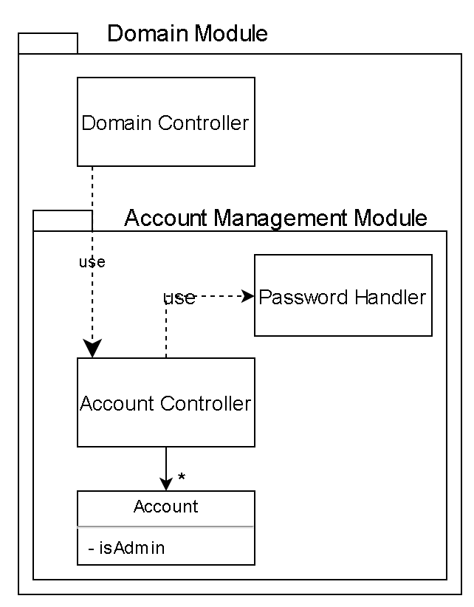

**DELETE THIS PAGE**

# Restrictions

**טיפול בדרישות רמת שירות:**

**פרטיות:**

1. המערכת שרצה על מכשיר הלקוח תצפין את הסיסמא שמוזנת ע"י המשתמש באמצעות פונקציית Hash חד כיוונית, אשר המחלקה Password Handler תעשה שימוש כדי לבדוק את התאמתה אל המשתמש. כנגזרת לכך, הסיסמאות יישמרו כתוצאות פונקציית ה-Hash ולא כסיסמא.

**חיוות משתמש:**

3.b. המערכת תציג שגיאה כאשר היא נכשלת בביצוע המטלה המבוקשת. המערכת תכיל עמוד ובו פירוט אודות הפונקציות במערכת ואופן השימוש בהן, בהתאם להרשאות המשתמש. בתפריט הפונקציות תהיה דוגמא קצרה המפרטת כיצד ניתן להשתמש בכל פונקציה.

**טיפול באילוצי נכונות:**

1. כל משתמש ייוצג ע"י כתובת דוא"ל ייחודית אשר נכונותה תיבדק בעת ההרשמה.
2. מנהל המערכת הראשון במערכת יקודד בעת בניית המערכת. כל מנהל מערכת אחר יוכל להירשם כמנוי.
3. המערכת מאפשרת מינוי בעל חנות ו/או מנהל חנות רק מתוך מאגר המשתמשים הקיים במערכת.
4. דרישה זו מתקיים ע"פ יחס הריבוי בין המחלקה Shop Management לבין Owner.
   1. סוגי הקניה מאושרים עבור כל מוצר נשמרים במחלקת אסוציאציה בשם Purchase Type, אשר מגדירה את אופן הקנייה המאושר עבור כל מוצר. בנוסף, עבור כל מוצר, מחלקת ה-Discount Policies מגדירה את ההנחה שמוגדרת לו. לדוגמא, הנחות על פריט מסויים יוגדרו כ"הנחה עבור פריטים בעלי מס' מוצר השווה ל...".
   2. החנות (Shop Warehouse) מחזיקה במחלקה Discount Policies אשר מקבלת פרטים אודות הקנייה, ומחזירה את ההנחה הרלוונטית עבורה, במידה וקיימת. סוגי הרכישה נשמרים במחלקה Purchase Policy Handler, אשר מתפקדת כ"שומר" (Guard) עבור רכישות לפי תנאי סף מוגדרים מראש.
5. עגלת הקניות של המשתמש מיוצגת כאוסף כל סלי הקניות של המשתמש עבור כלל החנויות במערכת. יש לציין כי סוג הקנייה "קנייה מיידית" (Regular) הינו סוג הקנייה היחיד שנשמר ב-Shopping Basket.
6. שכבת ה-Domain תמנע הפעלה של פעולות הקשורות לעגלת הקניות של המשתמש אם המשתמש המבצע אינו המשתמש אליו עגלת הקניות שייכת.
   1. דרישה זו תיאכף ע"י תרחיש קבלה - עבור כל רכישה, סכום החיוב הינו שווה לסכום המוצרים בסלי הקניות שנרכשו, בהתאם למדיניות ההנחות והרכישה.
   2. מערכת ה-Payment Handler תתריע למערכת אודות הצלחת חיוב ו/או כישלון, ובכך המערכת תעודכן בנוגע להצלחת תהליך הרכישה.
   3. מערכת התשלומים החיצונית תעביר את התשלום אל המוכר אם ורק אם התשלום התבצע בהצלחה.
   4. המערכת לא תאפשר הוספת הרשאה הנוגדת את כללי ההרשאות באמצעות המחלקה Permissions.
   5. דרישה זו נאכפת באמצעות המחלקה Payment Handler.
   6. דרישה זו נאכפת באמצעות המחלקה Delivery Handler.

# Glossary

|  |  |  |
| --- | --- | --- |
| **Term** | **Category** | **Definition** |
| Active discount | Store data | A discount whose end time is later than the current time. |
| Add product permissions | Permission | The ability to add a product to a store |
| Admin | User type | A user who is responsible for the management of the system, and can perform inter-store actions. |
| Admin menu | Menu | The menu in which the admin performs administrative operations in the system. |
| Auction | Purchase type | A purchase type in which customers place a bid on the item. When the auction end time has passed, the customer with the highest bid is charged and is granted the product. |
| Auction end time | Auction term | The time at which an auction ends. |
| Bid | Auction term | A monetary value placed by a customer on an item which is sold in an auction. At the time of placing, it has the highest value out of all the bids, and has to be larger than the minimum bid price which was set by the store. |
| Category | Item data | A data field which indicates the type of product |
| Client session | System | The time interval when client interacts with the system |
| Conditioned discount | Discount type | A discount which is applied if the set of conditions is met. |
| Current winning bid | Auction term | The bid with the highest value. |
| Customer | User type | A guest or a registered user |
| Default permissions | Store data | Store management information permission |
| Description | Item data | A text indicating the nature of the product. |
| Discount | Store data | A reduction in the price of the product. Applied according to the store's discount policies. It has a discount value and an end time. It is only applied if the discount is an active discount. |
| Discount policy | Policies | The limitations on the use of discount types at the store. |
| Discount type | Store data | The method used to reduce an item's price by the customer. Includes visible, conditioned and hidden discounts. |
| Edit or remove product permissions | Permission | The ability to edit or remove products from the store |
| Filter | Search data | A condition which items have to match in order to be displayed |
| Goal price | Lottery term | The value required to reach by the total submissions for a lottery item. After reaching the goal price, the lottery is performed. |
| Guest | User type | A non registered user |
| Hidden discount | Discount type | A discount which is applied if the customer applies a coupon which a manager/owner sets for the discount. |
| Item search result menu | Menu | A menu which is displayed to customers after they perform a search. It displays all and only the items which match the search term. |
| Leading bidder | Auction term | The customer who placed the current highest value winning bid. |
| Login | System | The transition of a guest to an existing registered user by authenticating using user email and password |
| Login page | Menu | The menu in which a guest attempts to login |
| Logout | System | The transition of a customer from a registered user to a guest. |
| Lottery end time | Lottery term | The time at which a lottery ends. |
| Lottery participants | Lottery term | All the users who paid to participate in a lottery purchase of an item. |
| Lottery purchase | Purchase type | A purchase type in which customers place a submission price in order to purchase the item. Upon submission, the customer is charged the submission price. When the total submissions reaches the goal price, the lottery ends and the product is granted to a random customer, each having a chance equal to their submission price percentage of the goal price. |
| Manager | User type | A user who was promoted by an owner to manage a store. A manager has a set of permissions, according to which he is allowed to act. |
| Minimum bid price | Auction term | The minimum value which has to be surpassed by all bids on the item. |
| Offer purchase | Purchase type | A purchase type in which customers place a monetary offer for the item. The offer is then presented to the store's management, who may accept or decline it. An accepted offer results in the customer being charged for the value of the offer, and grants him the product. |
| Original owner | User type | The customer who first opened the store |
| Password | Data field | A 4 characters or longer string of text |
| Payment system | System | The external system which charges a customer for its basket and transfers the revenue to the shop owner |
| Policy modification permissions | Permission | The ability to add or remove purchase and discount policies |
| Product | Store data | The data fields representing a product in the system. Includes a product name, price, description, categories |
| Product name | Item data | The name given to the product by the owner/manager |
| Product page | Menu | A menu which displays information regarding the product. The information includes all the information the product holds (see *product*), as well as its purchase type and applicable discount. |
| Promoter | Store data | For a promotee, it is the owner who promoted him. Only the original owner doesn't have a promoter. |
| Purchase | System | The acquisition of a basket's items by the user |
| Purchase history | User items | A collection of all the user's purchased baskets and purchased items. It holds the information true to the time of purchase. |
| Purchase menu | Menu | The menu which is displayed to customers after opening the system |
| Purchase policy | Policies | The limitations on the use of purchase policies at the store. |
| Purchase type | Item data | The method used to purchase an item. It includes auctions, lotteries, regular and offers. |
| Registered user | User type | A user who performed a registration and whose details are saved in the system |
| Registration page | Menu | The page in which a guest attempts to become a registered user |
| Regular purchase | Purchase type | A purchase in which the customer purchases and is charged immediately. The purchase is complete after a successful charge. |
| Role | User type | Any of the user types |
| Role selection menu | Menu | The menu in which a registered user who performed a successful login chooses his role according to the roles assigned to him |
| Search keyword | Search data | A word to be matched with the following fields: product name, description, category, creation date, store name |
| Shopping basket | User items | A collection of all of the user's saved items from a selected store. This represents the collection of items the user intends to purchase. |
| Shopping cart | User items | A collection of all of the user's shopping baskets |
| Shopping cart menu | Menu | The menu in which the system displays all the baskets in the user's shopping cart. For each basket, it displays the products, their amount and their price after discount. |
| Store creation menu | Menu | The menu in which a registered user creates a new store. Upon creation, the user is set as the original owner |
| Store information | Store data | The data fields representing the store's information. This includes the store's name, original owner, categories of items sold by the store, and store ranking |
| Store management data | Store data | The information regarding the store's managers, owners and their respective permissions |
| Store management information permission | Permission | The ability to view management information regarding the store. |
| Store management menu | Menu | The menu in which store owners and managers perform actions and view information regarding the store. |
| Store purchase history permissions | Permission | The ability to view information regarding all the purchases made by users at the store. |
| Store ranking | Store data | The average rank given to the store by customers who purchased items from it. |
| Store Warehouse | Store data | The products available for purchase at the respective store. |
| Submission price | Lottery term | The value charged from the user for the chance to receive the product. |
| Total submissions | Lottery term | The sum of all the submission prices placed on a lottery item. |
| User email | Data field | A text matching a legal email address, and is unique in the system |
| Visible discount | Discount type | A discount which is immediately applied to applicable items. |

# Use cases

|  |  |
| --- | --- |
| ***Use case no.:*** | 1 |
| ***Use case:*** | New user visit |
| ***Requirement number:*** | 2.1 |
| ***Actor:*** | A customer |
| ***Precondition:*** | No user is logged in the current session |
| ***Parameter:*** | None |
| ***Action:*** | 1. The system presents the customer the purchase menu and an option to enter the login or register menu.  2.1 If the customer doesn’t login, and chooses to continue to the purchase menu the system treats him as a guest.  2.2 Else, it chooses to enter the login/register menu. |

|  |  |
| --- | --- |
| ***Use case no.:*** | 2 |
| ***Use case:*** | Program exit |
| ***Requirement number:*** | 2.2 |
| ***Actor:*** | A customer |
| ***Precondition:*** | None |
| ***Parameter:*** | None |
| ***Action:*** | 1. The system will present the customer with an option to exit the program at the purchase menu or the admin menu.  2. If the customer chooses to exit, its client session will terminate. |

|  |  |
| --- | --- |
| ***Use case no.:*** | 3 |
| ***Use case:*** | Customer registration |
| ***Requirement number:*** | 2.3 |
| ***Actor:*** | A customer |
| ***Precondition:*** | The customer is a guest and he is on the registration page |
| ***Parameter:*** | user email, password |
| ***Action:*** | 1. The system asks the user to enter an email and a password  2. The user types an email and a password.  3.1 If the user email doesn’t belong to an existing registered user. Then, a new account for the user will be created, whose email and password will match the parameters.  3.2.1 Else, the system will present an error which indicates that the email is taken.  3.2.2 Repeat step 1.  4. The system redirected the newly registered user to the purchase menu. |

|  |  |
| --- | --- |
| ***Use case no.:*** | 4 |
| ***Use case:*** | Customer login |
| ***Requirement number:*** | 2.4 |
| ***Actor:*** | A customer |
| ***Precondition:*** | A customer in the login page. |
| ***Parameter:*** | user email, password |
| ***Action:*** | 1. The system asks the user to enter an email and a password.  2. The user types an email and a password.  3.1.1 If the email belongs to an existing account, and the typed password matches that account’s password, the session will belong to that user.  3.1.2 The user is redirected to the role selection menu.  3.2 Else, the system will present an error which indicates the credentials are wrong. |

|  |  |
| --- | --- |
| ***Use case no.:*** | 5 |
| ***Use case:*** | Store warehouse browsing |
| ***Requirement number:*** | 2.5 |
| ***Actor:*** | A customer |
| ***Precondition:*** | The customer is in the purchase menu |
| ***Parameter:*** | Store name (optional) |
| ***Action:*** | 1. The purchase menu will contain an option to view all the stores, or to search a store by name.  2. If the customer chooses a store from the store list, jump to 4.  3. The customer enters a store name  3.1 The system searches and presents to the customer the list of stores that matches that store name  3.2 The customer chooses a store from the search result  4. The system will present the user with the following:  4.1 Product search in the store’s warehouse.  4.2 Store information.  4.3 Products list from the store’s warehouse. |

|  |  |
| --- | --- |
| ***Use case no.:*** | 6 |
| ***Use case:*** | Item search |
| ***Requirement number:*** | 2.6 |
| ***Actor:*** | A customer |
| ***Precondition:*** | The customer is in the purchase menu |
| ***Parameter:*** | One of the following: Item name, category, search keyword. |
| ***Action:*** | 1. The purchase menu will contain an option to search products by one of the following search terms:  Item name  category  keyword  2. The user enters a search term and is transitioned to an item search result menu, which contains all the items which fit the search term.  3. The system will present the user with optional filters.  3.1 The user chooses filters  3.2 The system presents to the user the list of products that match the chosen filters.  4.1 The user may choose a product.  4.1.1 The system presents the user the product page.  4.2 The user exits from the item search result menu. |

|  |  |
| --- | --- |
| ***Use case no.:*** | 7 |
| ***Use case:*** | Add item to basket |
| ***Requirement number:*** | 2.7 |
| ***Actor:*** | A customer |
| ***Precondition:*** | The customer is in the product page of an item which is sold as a regular purchase. |
| ***Parameter:*** | Product to add (the current product the customer watches), amount of that product to add. |
| ***Action:*** | 1. The system will present the user with an option to save the item to the user’s basket in the store where the product is sold.  2.1 If the user chooses to add, the system will ask the user to choose an amount  2.1.1 if the store to which the item belongs to has an equal or larger amount of the item in the inventory, the item will be added to the user’s basket in the store and will be presented with an appropriate message.  2.2 Else the system will present the user an error which indicates that the store doesn’t have enough of the item in the inventory. |

|  |  |
| --- | --- |
| ***Use case no.:*** | 8 |
| ***Use case:*** | Shopping cart information and edit |
| ***Requirement number:*** | 2.8 |
| ***Actor:*** | A customer |
| ***Precondition:*** | A customer is in the purchase menu |
| ***Parameter:*** | None |
| ***Action:*** | 1. The purchase menu will contain an option to navigate to the shopping cart menu.  2. When the user navigates to that menu, they will be presented with their shopping cart, divided by baskets.  3. The user chooses one of his baskets.  4. The system presents the contents of the chosen basket to the customer.  5 . For each item presented, the customer may choose to modify the amount of the product, or to remove the item from the basket  5.1 If the user chose to remove the item, the system will remove the item from the basket and the user will not see it in the basket.  5.2 If the user edits the amount:  5.2.1 If the user chooses an amount larger than the current store’s inventory amount of the product, the system will produce an appropriate response and change the amount to the original value.  5.2.2 Else the amount will be updated according to the customer input. |
|  |  |

|  |  |
| --- | --- |
| ***Use case no.:*** | 9 |
| ***Use case:*** | Product purchase of regular purchase items |
| ***Requirement number:*** | 2.9 |
| ***Actor:*** | A customer |
| ***Precondition:*** | A customer in the shopping cart menu. |
| ***Parameter:*** | None |
| ***Action:*** | 1. If the cart doesn’t have any shopping baskets the system presents to the customer appropriate message  2. For each basket in the cart, the system will present the user an option to purchase all the items in the basket.  3. The user chooses a basket.  4.1 If all the amounts of items in the basket are below or equal to the store’s inventory for each item, the system will reduce the amount for each, and the user will move to the external payment system.  4.2 Else, the customer will be presented with a message which indicates which item is below the store’s inventory amount, and will transition to use case no. 8.  5.1. If the payment system indicates that a successful purchase was made, the system will save the current basket in the user’s purchase history and will remove it from the user’s cart.  5.2 Else, the user will be presented with an appropriate error message and the inventory amount for each item will revert back to its original value. |

|  |  |
| --- | --- |
| ***Use case no.:*** | 10 |
| ***Use case:*** | Product bid of items sold in auctions |
| ***Requirement number:*** | 2.9 |
| ***Actor:*** | A registered customer |
| ***Precondition:*** | A customer in the product page of an auction item whose auction end time is later than the current time. |
| ***Parameter:*** | Bid price |
| ***Action:*** | 1. The product page will display an option to bid an amount on the item  2.1 If the user enters an amount and the amount is not higher then the highest current bid.  2.2 The system checks if the amount is larger than the minimum bid price and the current winning bid, if not the system presents an appropriate error message to the user. Go to step 1 again.  2.3 The system will check if he bid before on the item. If he did, the system will use his previous payment method, and if he didn’t he will be asked to enter them.  2.4 The user will become the leading bidder and his offer will become the current winning bid.  2.4.1 The system will notify the last leading bidder that his bid was outbid.  2.5 If the user is not the leading bidder (caused by parallel bids) then display an appropriate message and move to step 1.  2.6 Move to use case no. 11 |

|  |  |
| --- | --- |
| ***Use case no.:*** | 11 |
| ***Use case:*** | Product purchase of items sold in auctions |
| ***Requirement number:*** | 2.9 |
| ***Actor:*** | A registered customer |
| ***Precondition:*** | The current time is equal or larger than the auction end time. |
| ***Parameter:*** | Product , payment information. |
| ***Action:*** | 1. The system will charge the payment method of the leading bidder.  2. Notify the customer and add the purchase to the user’s purchase history. |

|  |  |
| --- | --- |
| ***Use case no.:*** | 12 |
| ***Use case:*** | Product offer purchase |
| ***Requirement number:*** | 2.9 |
| ***Actor:*** | A registered customer |
| ***Precondition:*** | The user is in the product page of a product sold in a purchase offer |
| ***Parameter:*** | Product |
| ***Action:*** | 1. The system will display an option to send an offer to purchase the item.  2. If the user attempts to offer, he will be asked to enter an amount and to enter his payment method.  3. All the managers at the store will receive a notification regarding the offer. It will state the item, and the offer amount.  4.1 If the manager accepts the offer, the user’s payment method will be charged.  4.1.1 The user will receive a notification and the purchase will be saved in his purchase history.  4.2 If the manager declines the offer the user will receive a denial notification.  4.3 If the manager wants to suggest a counter offer the user will receive a notification with the product name and the requested counter offer price.  4.3.1 If the user accepts the counter offer he will be charged with his payment info and the item will be added to his purchase history.  4.3.2 Else the manager will be notified that his counter offer was rejected by the user. |

|  |  |
| --- | --- |
| ***Use case no.:*** | 13 |
| ***Use case:*** | Product lottery purchase |
| ***Requirement number:*** | 2.9 |
| ***Actor:*** | A registered customer |
| ***Precondition:*** | The user is in the product page of a product sold in a lottery, which hadn't reached its goal price |
| ***Parameter:*** | Submission price |
| ***Action:*** | 1. The system will display an option to pay a submission price for an item.  2.1 If the user enters a submission price which matches  [submission price <= goal price - total submissions], then he will be asked to enter his payment method and will be charged accordingly , and the total submission will accumulate his submission.  2.1.1 Jump to use case 14  2.2 Else, the system will display an appropriate message that the submission price is invalid. |

|  |  |
| --- | --- |
| ***Use case no.:*** | 14 |
| ***Use case:*** | Lottery winning |
| ***Requirement number:*** | 2.9 |
| ***Actor:*** | A registered customer |
| ***Precondition:*** | A product sold in a lottery reaches its goal price or the lottery end time has elapsed |
| ***Parameter:*** | None |
| ***Action:*** | 1. If the lottery end time is reached without achieving the desired goal price.  1.1 The system will notify all the lottery participants that the lottery did not reach its goal within the end time limit.  2. Else The system will choose randomly a winner. The winner will be picked with a chance equal to the percentage of the goal price he paid for.  3. All the lottery participants will receive a notification regarding the lottery with a notification which indicates whether they won the lottery or not.  4. If the user won the lottery the product will be put in his purchase history. |

|  |  |
| --- | --- |
| ***Use case no.:*** | 15 |
| ***Use case:*** | Logout |
| ***Requirement number:*** | 3.1 |
| ***Actor:*** | A customer |
| ***Precondition:*** | A logged user in the purchase menu. |
| ***Parameter:*** | None |
| ***Action:*** | 1. The system will present an option to logout from the purchase menu.  2. If the customer chooses to logout he will be redirected to use-case 1. |

|  |  |
| --- | --- |
| ***Use case no.:*** | 16 |
| ***Use case:*** | Store opening |
| ***Requirement number:*** | 3.2 |
| ***Actor:*** | A customer |
| ***Precondition:*** | A logged user in the purchase menu. |
| ***Parameter:*** | store name, discount policy, purchase policy, bank account, payment information. |
| ***Action:*** | 1. The system will present an option to open a new store.  2. If the user chooses to open a new store the system will redirect the user to a store creation menu.  3. The system will ask the customer to choose:  Store name.  Discount policies.  Purchase policies.  Bank account.  Payment information.  4. The system will assign the customer as the store original owner.  5. The system will save the new store.  6. The system will redirect the customer to the store management menu. |
|  |  |

|  |  |
| --- | --- |
| ***Use case no.:*** | 17 |
| ***Use case:*** | Purchase history |
| ***Requirement number:*** | 3.7 |
| ***Actor:*** | A customer |
| ***Precondition:*** | A logged user in the shopping cart menu. |
| ***Parameter:*** | None |
| ***Action:*** | 1. The system will present an option to view the customer’s purchase history.  2. If the customer chooses to view his history the system will display the purchase history. |

|  |  |
| --- | --- |
| ***Use case no.:*** | 18 |
| ***Use case:*** | Add a product to a store. |
| ***Requirement number:*** | 4.1 |
| ***Actor:*** | A manager/owner. |
| ***Precondition:*** | An owner or a manager who has permissions to add products. |
| ***Parameter:*** | Product name, purchase type, amount, price, category, description, Shop id |
| ***Action:*** | 1. The system will present an option to add a new item to the store.  2. If the option to add an item is chosen, the actor will need to provide the following parameters:  Product name (not empty)  Purchase type.  Amount (more than 0).  Price (more than 0)  Categories  Description  Shop id  2.1 If the parameters are valid and the purchase type exists in the store’s purchase types and the purchase policy allows the item to be sold, by the system a new product will be added to the shop.  2.2 Else the system will display an appropriate error message, and return to step 1. |

|  |  |
| --- | --- |
| ***Use case no.:*** | 19 |
| ***Use case:*** | Edit/Remove a product. |
| ***Requirement number:*** | 4.1 |
| ***Actor:*** | A manager/owner. |
| ***Precondition:*** | Manager with edit or remove product permissions or an owner. |
| ***Parameter:*** | Shop id, product id, One of the following: amount, price, category, description. |
| ***Action:*** | 1. The system will present an option to edit/remove an item from the store.  2. If the option to remove an item is chosen, the actor will need to provide the product ID(not empty)  3. If the option to edit an item is chosen, the actor will need to provide the following parameters:  Product ID(not empty)  Amount(Optional)  Price(Optional)  Categories(Optional)  Description(Optional)  2.1 If the parameters are valid by the system the edited information will be updated. Valid information is:  Product ID exists in the system for the shop id, the product ID belongs to an item sold in a regular purchase, the amount is non-negative or the price is non-negative.  2.2 Else the system will display an appropriate error message. |

|  |  |
| --- | --- |
| ***Use case no.:*** | 20 |
| ***Notes:*** | *This Use case is not complete as the store policies are yet to be set* |
| ***Use case:*** | Edit/add/display a store purchase policy. |
| ***Requirement number:*** | 4.2 |
| ***Actor:*** | A manager/owner. |
| ***Precondition:*** | A manager with policy modification permissions or an owner. The actor is within the store management-menu. |
| ***Parameter:*** | Store policy(Optional), shop id |
| ***Action:*** | 1. The system will display the store management-menu to the actor with the following options:  A) Add B) Edit C) Display.  2. A: The user will provide details of a new store policy.  3. B: The user will provide new values to an existing store policy.  4. C: The system will display all the store policies to the user. |

|  |  |
| --- | --- |
| ***Use case no.:*** | 21 |
| ***Notes:*** | *This Use case is not complete as the discount policies are yet to be set* |
| ***Use case:*** | Edit/add/display a discount policy. |
| ***Requirement number:*** | 4.2 |
| ***Actor:*** | A manager/owner. |
| ***Precondition:*** | A manager with policy modification permissions or an owner. The actor is within the store management-menu. |
| ***Parameter:*** | Discount policy(Optional), shop id |
| ***Action:*** | 1. The system will display the store management-menu menu to the actor with the following options:  A) Add B) Edit C) Display.  2. A: The user will provide details of a new discount policy.  3. B: The user will provide new values to an existing discount policy.  4. C: The system will display all the discount policies to the user. |

|  |  |
| --- | --- |
| ***Use case no.:*** | 22 |
| ***Use case:*** | Remove/add/display a store’s purchase type |
| ***Requirement number:*** | 4.2 |
| ***Actor:*** | A manager/owner. |
| ***Precondition:*** | A manager with policy modification permissions or an owner. The actor is within the store management-menu. |
| ***Parameter:*** | Purchase type, shop id |
| ***Action:*** | 1. The system will display the option menu to the actor with the following option:  A) Add B) Remove C) Display.  2. A: The user will enter the new purchase type. The purchase type will be added to the store’s allowed purchase types.  3. B: The user will provide the purchase type he wants to remove from the store. If the purchase type is allowed by the store, it will become disallowed. Any current item’s which are offered by the store with the selected purchase type will still be sold in this method.  4. C: The system will display all the purchase type’s available in the store. |

|  |  |
| --- | --- |
| ***Use case no.:*** | 23 |
| ***Use case:*** | Remove/add/display a store’s discount type |
| ***Requirement number:*** | 4.2 |
| ***Actor:*** | A manager/owner. |
| ***Precondition:*** | A manager with policy modification permissions or an owner. The actor is within the store management-menu. |
| ***Parameter:*** | shop id, (all optional) - Discount type, Product Id, End time, discount amount, condition, coupon code |
| ***Action:*** | 1. The system will display the option menu to the actor with the following option:  A) Add B) Remove C) Display.  2. A: The user will enter the new discount type and a product Id. If the product is sold in a purchase type other than regular purchase, the system will display an appropriate message and return to step 1.  2.1 If the discount type is visible, the actor will provide the discount percentage, and the end time.  2.2 If the discount type is a conditioned discount the actor will provide the discount percentage and the discount condition and the end time.  2.3 If the discount type is a hidden discount, the actor will provide the discount percentage, the coupon code and the end time.  3. B: The user will enter the product id and the discount id. The system will remove the discount from its item, if the product id exists and it contains a discount with the given discount id.  4. C: The system will display all the active discounts in the store. |

|  |  |
| --- | --- |
| ***Use case no.:*** | 24 |
| ***Use case:*** | Promote a registered user to ownership of shop |
| ***Requirement number:*** | 4.3 |
| ***Actor:*** | An owner. |
| ***Precondition:*** | The promotee is not already an owner of that shop, the owner is in the shop management menu |
| ***Parameter:*** | Shop, User (Promotee) |
| ***Action:*** | 1. The owner gives to the system the user id  2. The system assigns this user as an owner of that shop, and assigns the owner as the promoter of the new promotee. |

|  |  |
| --- | --- |
| ***Use case no.:*** | 25 |
| ***Use case:*** | Promote a registered user to management the shop |
| ***Requirement number:*** | 4.5 |
| ***Actor:*** | An owner. |
| ***Precondition:*** | The promotee is not already an owner or a manager of that shop, the owner is in the shop management menu |
| ***Parameter:*** | Shop ID, User ID (Promotee) |
| ***Action:*** | 1. The owner gives to the system the user id  2. The system assigns this user as an manager of that shop, and assigns the owner as the promoter of the new promotee.  3. The system assigns the default permissions to the promotee. |

|  |  |
| --- | --- |
| ***Use case no.:*** | 26 |
| ***Use case:*** | Manager permission management |
| ***Requirement number:*** | 4.6 |
| ***Actor:*** | An owner. |
| ***Precondition:*** | The owner is in the shop management menu. |
| ***Parameter:*** | User ID, permissions. |
| ***Action:*** | 1. The system displays the available permission in the system.  2. The owner enters the User ID of the manager whose permissions he wants to edit and selects the permissions he wants the manager to have.  3. The system checks if the User ID belongs to a manager of the store and the Owner is the promoter of the mentioned manager.  4. The system updates the permissions in case of valid input.  5. Else the system displays an appropriate error message. |

|  |  |
| --- | --- |
| ***Use case no.:*** | 27 |
| ***Use case:*** | Remove the manager of a selected store. |
| ***Requirement number:*** | 4.7 |
| ***Actor:*** | An owner. |
| ***Precondition:*** | The owner is in the shop management menu. |
| ***Parameter:*** | User ID. |
| ***Action:*** | 1. The system asks the owner to enter a user id which he wants to remove from the store.  2. The owner enters an ID.  3. If the provided User ID belongs to a manager of the current store and the promoter of the manager is the current actor the system will remove the User ID from the store management. In addition, The system will end any session the manager had in the system.  4. Else the system will display an appropriate error message. |

|  |  |
| --- | --- |
| ***Use case no.:*** | 28 |
| ***Use case:*** | Display information about the store managers. |
| ***Requirement number:*** | 4.9 |
| ***Actor:*** | A manager/owner. |
| ***Precondition:*** | Manager with store management information permission or an owner. The actor is in the store management menu. |
| ***Parameter:*** | None |
| ***Action:*** | 1. The system displays the option to display store management data.  2. The actor chooses to see the store management data.  3. The system displays all the Owners and managers of the current store and their permissions. |

|  |  |
| --- | --- |
| ***Use case no.:*** | 29 |
| ***Use case:*** | Display the current store order history. |
| ***Requirement number:*** | 4.11 |
| ***Actor:*** | An owner/Manager. |
| ***Precondition:*** | Manager with display store purchase history permissions or an owner. The actor is in the store management menu. |
| ***Parameter:*** | Shop ID. |
| ***Action:*** | 1. The system displays the option to display store purchase history data.  2. The actor chooses to see the store purchase history.  3. The system displays all the past orders of the current store. |

|  |  |
| --- | --- |
| ***Use case no.:*** | 30 |
| ***Use case:*** | See a user’s purchase history - admin view |
| ***Requirement number:*** | 6.4 |
| ***Actor:*** | System admin |
| ***Precondition:*** | The admin is in the admin-menu |
| ***Parameter:*** | User id |
| ***Action:*** | 1. The system will present the actor with an option to view a user’s purchase history.  2. The admin will enter the User id. If the id belongs to an existing user, it will display the user’s purchase history.  3. If the id doesn’t belong to an existing user, the system will display an appropriate message. |

|  |  |
| --- | --- |
| ***Use case no.:*** | 31 |
| ***Use case:*** | See a store’s purchase history - admin view |
| ***Requirement number:*** | 6.4 |
| ***Actor:*** | System admin |
| ***Precondition:*** | The admin is in the admin-menu |
| ***Parameter:*** | Shop ID |
| ***Action:*** | 1. The system will present the admin with an option to view a store’s purchase history.  2. The admin will enter the store id. If the id belongs to an existing store, it will display the store’s purchase history.  3. If the id doesn’t belong to an existing store, the system will display an appropriate message. |

# Acceptance tests

|  |  |  |  |
| --- | --- | --- | --- |
| Use Case No.1 | | | |
| Scenario | Action | Data | Expected Result |
| Good | User starts new session with the system | None | The system presents the customer the purchase menu and an option to enter the login or register menu |
| Sad | the User enters an input which doesn’t match an entry in the current menu | User input | The system presents an appropriate error, reprints the menu and prompts for an input |
| Bad | User starts new session with the system, the server crashes | None | The system will present an appropriate message to the user and meanwhile it tries to reconnect. |

|  |  |  |  |
| --- | --- | --- | --- |
| Use Case No. 2 | | | |
| Scenario | Action | Data | Expected Result |
| Good | The user asks to exit the program | None | whatThe program gracefully terminates the client’s session. If the user is a guest, the program will delete its data. If the user is a registered user, it will save its data |
| Sad | The user terminates the program ungracefully | None | If the user is a guest, the program will delete its data. If the user is a registered user, it will save its data |
| Bad | The system is terminated | None | The system will recover without any data loss. |

|  |  |  |  |
| --- | --- | --- | --- |
| Use Case No.3 | | | |
| Scenario | Action | Data | Expected Result |
| Good | The user is in the registration menu and enters an email and a password. | UserID ,Valid email, Valid password | A new user is added to the system with the provided email and password and the system is redirected to the purchase menu. |
| Sad | The user is in the registration menu and enters an email and a password. | UserID, Already in use email, Valid password. | The system alerts the user that the email he entered is already in use. |
| Bad | The user is in the registration menu and enters an empty email address and an empty password. | UserID, Empty password,Empty email | The system alerts the user of invalid parameters by a prompt and redirects him to the registration menu again. |

|  |  |  |  |
| --- | --- | --- | --- |
| Use Case No.4 | | | |
| Scenario | Action | Data | Expected Result |
| Good | The user is in the login page and enters an email and a password. | UserID, Valid email and matching password. | The system validates the data and redirects the user to the role selection menu. |
| Sad | The user is in the login page and enters an email and a password. | UserID, Valid email and a non matching password of that email address. | The system prompts an error indicating that the credentials are wrong. |
| Bad | The user is in the login page and enters the maximum number of characters for any system input request. | UserID, Max char email, Max char password. | The system prompts an error indicating that the credentials are wrong. |

|  |  |  |  |
| --- | --- | --- | --- |
| Use Case No.5 | | | |
| Scenario | Action | Data | Expected Result |
| Good | The user asks to view all the stores. | None | The system will display all the stores that exist in the system. |
| Sad | The user asks to search a specific store by name and display the store information. | Shop ID, None existing store name. | The system will prompt an error message indicating that the store which the user selected does not exist. |
| Bad | The user asks to search a specific store by name and enters an empty field in the product search. | Shop ID, Valid store name, invalid name of product. | The system will prompt an error message indicating that the user input is invalid. |

|  |  |  |  |
| --- | --- | --- | --- |
| Use Case No.6 | | | |
| Scenario | Action | Data | Expected Result |
| Good | The user chooses to search an item by name and enters it in the search bar, then chooses to filter them by price. | Product name | The system displays all the stores that sell the requested product in the specified price. |
| Sad | The user chooses to search a category | Ivalid category name. | The system prompts an error indicating that the searched category doesn't exist. |
| Bad | The user chooses to search an item by name and filter the result by all existing filters. | Sensitive product Name (e.x : drop tables) | The system prompts an error indicating that data is invalid. |

|  |  |  |  |
| --- | --- | --- | --- |
| Use Case No.7 | | | |
| Scenario | Action | Data | Expected Result |
| Good | The user chooses to add the selected product to its user basket, and enters an amount. | Product ID, Product Name,Amount | The system will add the desired product to the user’s store basket with its specified amount. |
| Sad | The user chooses to add the selected product to its user basket and enters an amount. | Product ID, Product Name, amount that exceeds the amount specified in the store inventory. | The system will prompt an error indicating the chosen amount exceeds the amount of the store. |
| Bad | The user chooses to add the selected product to its user basket and enters an amount. | Product ID, Product Name,a negative product amount. | The system will prompt an error message indicating the data provided is invalid. |

|  |  |  |  |
| --- | --- | --- | --- |
| Use Case No.8 | | | |
| Scenario | Action | Data | Expected Result |
| Good | The user decides to view his shopping cart and chooses one of its baskets to view. | Basket name | The system displays the chosen basket information with all its products. |
| Sad | The user decides to view his shopping cart and chooses a basket. | Wrong basket name | The system prompts an error message indicating the data is invalid. |
| Bad | The user decides to view his shopping cart and chooses a basket and decides to edit one of the items in the basket, and enters an amount. | Basket name, product name, negative amount | The system will prompt an error message indicating the edit of the item contains invalid data. |

|  |  |  |  |
| --- | --- | --- | --- |
| Use Case No.9 | | | |
| Scenario | Action | Data | Expected Result |
| Good | The user is shown all its baskets and chooses to buy a specific basket and pays for the basket | Basket name, correct payment info | The system will scan the products of the basket and reduce the amount from the store warehouse, then it will redirect the user to an external payment system, after a successful payment the basket will be removed from the user’s shopping cart and will be in its purchase history. |
| Sad | The user is shown all its baskets and chooses to buy a specific basket. | Invalid basket name | The system will prompt an error message indicating that the provided data is invalid. |
| Bad | The user is shown all its baskets and chooses to buy a specific basket and when asked to pay for the basket he exits the current session. | Basket name, correct payment info | The system will close and revert all the changes to the amount of products in the store’s warehouse. |

|  |  |  |  |
| --- | --- | --- | --- |
| Use Case No.10 | | | |
| Scenario | Action | Data | Expected Result |
| Good | The user is registered and enters an amount to bid on the item and enters his payment info. | Product ID,Amount, Payment info | The system will ask the user to enter his payment method if it is his first bidding and change the leading bidder to user and alert the previous leading bidder that his bid was outbid. |
| Sad | The user is registered and enters an amount to bid on the item. | Product ID,Amount which is less than the current highest bid. | The system will prompt an error indicating the bidding amount is less than the current highest bid. |
| Bad | The user is registered and enters an amount to bid on the item and exits the session instead of paying. | Product ID,Amount | The system will not consider the user’s bid and maintain its previous state. |

|  |  |  |  |
| --- | --- | --- | --- |
| Use Case No.11 | | | |
| Scenario | Action | Data | Expected Result |
| Good | An auction end time has elapsed | Product (Product ID),  Customer Payment information | The system will notify the user for winning the auction. Also, the system will charge the customer’s Credit Card for the price of the item and will notify the user for making the charge. After that, the system will add the product to the user purchase history. |
| Sad | An auction end time has elapsed, but the user entered not the correct bank account details. | Product (Product ID), Customer Payment information | The system will try and fail to charge the user's Credit Card. Then it will notify the user for unsuccessful charge attempt |
| Bad | An auction end time has elapsed, and meanwhile the system was unavailable | Product (Product ID),  Customer Payment information | The system when the system will be available, it will check if the auction time has elapsed. In such a case, it will check if the payment for the auction was charged, if not it will charge it and behave as in the “Good case”. |

|  |  |  |  |
| --- | --- | --- | --- |
| Use Case No.12 | | | |
| Scenario | Action | Data | Expected Result |
| Good | The customer places an offer on a product and the manager receives the notification and accepts the offer. | Shop ID, Product ID, payment information, price. | The system notifies the manager that an offer was placed on an item, the manager views the offer and accepts.  The system charges the user with its payment information, notifies the user of a successful trade and places the item in his purchase history. |
| Sad | The customer places an offer on a product and the manager receives the notification and declines the offer. | Shop ID, Product ID, payment information, price. | The system notifies the manager that an offer was placed on an item, the manager views the offer and declines, the user is notified of the unsuccessful trade |
| Bad | The customer places an offer on a product and the owner of the shop remove the product from sale | Shop ID, Product ID, payment information, price | The system notifies the customer that the product is no longer available |

|  |  |  |  |
| --- | --- | --- | --- |
| Use Case No.13 | | | |
| Scenario | Action | Data | Expected Result |
| Good | The user enters the biggest and submission price for a product that is = goal price - total submission | Product (Product ID), Shop (Shop ID), payment info, Submission price | The system will charge the user for the submission price. The system will add the product to the purchase history. Then, it will choose randomly the winner from the lottery participants. Finally, it will notify all participants if they won or not. |
| Sad | The user enters a submission price which is bigger than the goal price for the lottery. | Product (Product ID), Shop (Shop ID), payment info, Submission price | The system prompts an error indicating that the amount entered is higher than the goal price. |
| Bad | The user enters a submission price and his payment information and the owner of the shop removes the product. | Product (Product ID), Shop (Shop ID), payment info, Submission price | The system notifies the customer that the product is no longer available |

|  |  |  |  |
| --- | --- | --- | --- |
| Use Case No.14 | | | |
| Scenario | Action | Data | Expected Result |
| Good | The goal price is reached before the end time. | User IDs,  Product (Product ID) | The system notifies all the users who participated in the lottery that the goal price was reached and whether they won the lottery and adds the product to all the participants’ purchase history. |
| Sad | None | None | None |
| Bad | The system is unavailable while the end time has elapsed. | User IDs,  Product (Product ID) | The manager will be notified and all the participants will be refunded and notified. |

|  |  |  |  |
| --- | --- | --- | --- |
| Use Case No.15 | | | |
| Scenario | Action | Data | Expected Result |
| Good | A logged in user asks to logout (while in the purchase menu) | None | The system will log the user out, save the session’s data, and present the purchase menu again. |
| Sad | None | None | None |
| Bad | A guest user asks to log out (without ever logging in) | None | The system will display a message saying in order to log out you must first log in, and display the purchase menu. |

|  |  |  |  |
| --- | --- | --- | --- |
| Use Case No.16 | | | |
| Scenario | Action | Data | Expected Result |
| Good | A user asks to open a new store and enters all the required fields legally. | Store name, Discount policies, Purchase policies, Bank account, Payment information. | The system creates the store, assigns the customer as it’s original owner and redirects the user to the store management menu. |
| Sad | A user asks to open a new store but accidentally doesn’t insert the last digit of his bank account number. | Store name, Discount policies, Purchase policies, Illegal bank account, Payment information. | The system shows an error regarding the length of a legal bank account number and lets the user re-enter the information. |
| Bad | A user asks to open a new store but enters an empty store name. | Empty store name, Discount policies, Purchase policies, Bank account, Payment information. | The system shows an error regarding an empty store name and lets the user re-enter the information. |

|  |  |  |  |
| --- | --- | --- | --- |
| Use Case No.17 | | | |
| Scenario | Action | Data | Expected Result |
| Good | A user asks to view his purchase history. | None | The system presents a list of the user’s previous purchases. |
| Sad | A user asks to view his purchase history but he has none. | None | The system will present a message saying the user has yet to make any purchases. |
| Bad | None | None | None |

|  |  |  |  |
| --- | --- | --- | --- |
| Use Case No.18 | | | |
| Scenario | Action | Data | Expected Result |
| Good | A store manager/owner adds a product to his store. | Product name, purchase type, amount, price, category, description, Shop id | The system adds the product to the appropriate store. |
| Sad | A store manager/owner adds a product to his store but enters a purchase type that does not exist in that store | Product name, purchase type, amount, price, category, description, Shop id | The system presents an error regarding the store’s available purchase types, and lets the user re enter the data. |
| Bad | A user tries to add a product to a store he doesn’t have the permissions to. | Product name, purchase type, amount, price, category, description, Shop id | The system presents an error regarding the user’s permissions and reprints the menu. |

|  |  |  |  |
| --- | --- | --- | --- |
| Use Case No.19 | | | |
| Scenario | Action | Data | Expected Result |
| Good | A manager/owner asks to remove a product from his store. | Product ID | The system removes the product from the store and reprints the menu. |
| Sad | A manager/owner asks to remove a product from his store but the product ID he provides is invalid | Product ID | the system presents an error regarding the illegal product ID and reprints the menu. |
| Bad | A user asks to remove a product from a store he does not have permissions to. | Product ID | The system presents an error regarding the user’s permissions and reprints the menu. |

|  |  |  |  |
| --- | --- | --- | --- |
| Use Case No.20 | | | |
| Scenario | Action | Data | Expected Result |
| Good | An owner/manager with permissions asks to add a store purchase policy | Purchase policy | The system will add the policy to the store and reprint the menu. |
| Sad | The owner or manager type incorrectly the purchase policy details | Purchase policy | The system will show appropriate message to the actor |
| Bad | A user asks to add a store purchase policy from a store he does not have permissions to. | Purchase policy | The system presents an error regarding the user’s permissions and reprints the menu. |

|  |  |  |  |
| --- | --- | --- | --- |
| Use Case No.21 | | | |
| Scenario | Action | Data | Expected Result |
| Good | An owner/manager with permissions asks to add a store discount policy | Discount policy | The system will add the policy to the store and reprint the menu. |
| Sad | The owner or manager type incorrectly the discount policy details | Discount policy | The system will show appropriate message to the actor |
| Bad | A user asks to add a store discount policy from a store he does not have permissions to. | Discount policy | The system presents an error regarding the user’s permissions and reprints the menu. |

|  |  |  |  |
| --- | --- | --- | --- |
| Use Case No.22 | | | |
| Scenario | Action | Data | Expected Result |
| Good | An owner/manager with permissions asks to add a store purchase type | Purchase type | The system will add the purchase type to the store and reprint the menu. |
| Sad | An owner/manager with permissions asks to add a store purchase type but the store already has that purchase type | Purchase type | The system presents an error saying this purchase type already exists and reprints the menu. |
| Bad | A user asks to add a store purchase type from a store he does not have permissions to. | Purchase type | The system presents an error regarding the user’s permissions and reprints the menu. |

|  |  |  |  |
| --- | --- | --- | --- |
| Use Case No.23 | | | |
| Scenario | Action | Data | Expected Result |
| Good | An owner/manager with permissions asks to add a store discount type | Discount type | The system will add the policy to the store and reprint the menu. |
| Sad | The owner or manager tries to add a discount type that is not in the discount policy of the shop | Discount type | The system will show appropriate message to the actor |
| Bad | A user asks to add a store discount type from a store he does not have permissions to. | Discount type | The system presents an error regarding the user’s permissions and reprints the menu. |

|  |  |  |  |
| --- | --- | --- | --- |
| Use Case No.24 | | | |
| Scenario | Action | Data | Expected Result |
| Good | An owner of a shop chooses a registered user and promotes him to be an owner. | Valid shop id, Valid registered user id. | The chosen user became an owner of the shop. |
| Sad | An owner of a shop chooses a registered user and promotes him to be an owner. | Valid shop id, registered user id that’s already an owner of this shop. | The system prompts an error indicating that the input user is already an owner of the shop. |
| Bad | A user chooses a registered user and promotes him to be an owner. | Shop id that the user isn’t the owner of this shop, registered user id. | The system prompts an error indicating the user isn’t the owner of this shop. |

|  |  |  |  |
| --- | --- | --- | --- |
| Use Case No.25 | | | |
| Scenario | Action | Data | Expected Result |
| Good | An owner of a shop chooses a register user and promotes him to be a manager. | Valid shop id, Valid registered user id. | The chosen user became a manager of the shop. |
| Sad | An owner of a shop chooses a register user and promotes him to be a manager. | Valid shop id ,registered user id that’s already a manager or an owner of the shop. | The system prompts an error indicating the user is already a manager or an owner of this shop. |
| Bad | A user chooses a register user and promotes him to be a manager. | Shop id that the user isn’t the owner of this shop, registered user id. | The system prompts an error indicating the user isn’t the owner of this shop. |

|  |  |  |  |
| --- | --- | --- | --- |
| Use Case No.26 | | | |
| Scenario | Action | Data | Expected Result |
| Good | An owner of a shop sets or modifies management permissions for a manager that he promoted. | Valid registered user id, permissions. | The permissions of the chosen manager has been modified. |
| Sad | An owner of a shop sets or modifies management permissions for a manager that he promoted. | Valid registered user id, permissions that already exist. | The system won’t change a thing. |
| Bad | An owner of a shop sets or modifies management permissions for a manager that he promoted. | a manager that wasn't promoted by the user, permissions. | The system prompts an error indicating that the manager wasn't promoted by the owner. |

|  |  |  |  |
| --- | --- | --- | --- |
| Use Case No.27 | | | |
| Scenario | Action | Data | Expected Result |
| Good | An owner of a shop tries to remove a manager of that shop | Owner (User ID), Manager (User ID), Shop (Shop ID) | The system will remove the manager of that shop, it will delete his permissions. The system will end any session the manager had in the system. |
| Sad | An owner of a shop tries to remove a user that is not a manager of that shop | Owner (User ID), User to remove (User ID), Shop (Shop ID) | The system will not apply the changes, and will alert the owner that this user is not a manager. |
| Bad | A registered user that is not owner of a shop tries to remove a user that is a manager of that shop | Actor (User ID), Manager (User ID), Shop (Shop ID) | The system will not apply the changes and will alert the user that he doesn’t have the permission to do this action. |

|  |  |  |  |
| --- | --- | --- | --- |
| Use Case No.28 | | | |
| Scenario | Action | Data | Expected Result |
| Good | Manager with store management information permission or Owner, he wants to watch the shop's information | Manager or Owner (User ID), Shop (Shop ID) | The system will display to the actor the information of the shop |
| Sad | A user that is not an owner nor a manager of a shop with store management information permission, he wants to watch the shop's information | Manager (User ID),  Shop (Shop ID) | The system will display an error message that he doesn’t have the necessary permissions |
| Bad | Manager without store management information permission, he wants to watch the shop's information | Manager (User ID),  Shop (Shop ID) | The system will display an error message that he doesn’t have the necessary permissions |

|  |  |  |  |
| --- | --- | --- | --- |
| Use Case No.29 | | | |
| Scenario | Action | Data | Expected Result |
| Good | An owner or manager requests a purchase history of one of their shops. | Valid shop id. (in the use case there’s none parameters) | The system will display the purchase history of the shop. |
| Sad | An owner or manager requests a purchase history of one of their shops. | Non existing shop id. (in the use case there’s none parameters) | The system will prompt an error indicating the shop doesn’t exist. |
| Bad | A user that isn’t an owner or manager. | Valid shop id. (in the use case there’s none parameters) | The system prompts an error indicating the user isn’t an owner or a manager. |

|  |  |  |  |
| --- | --- | --- | --- |
| Use Case No.30 | | | |
| Scenario | Action | Data | Expected Result |
| Good | An admin wants to watch a purchase history of a specific user | Admin (User ID),  Observed User (User ID) | The system will present to the admin the user’s purchase history |
| Sad | An admin wants to watch a purchase history of a non existing user | Admin (User ID),  non existing User (User ID) | The system will present to the admin an error message that that user is not existing in the system |
| Bad | A non admin user wants to watch a purchase history of other a specific user | Non Admin (User ID),  Observed User (User ID) | The system will present to the user an error message that he is not authorized to do this. |

|  |  |  |  |
| --- | --- | --- | --- |
| Use Case No.31 | | | |
| Scenario | Action | Data | Expected Result |
| Good | The admin requests the purchase history of a specific shop. | Valid shop ID. | The system will display the purchase history of the shop. |
| Sad | The admin requests the purchase history of a specific shop. | Non existing shop ID. | The system will prompt an error indicating the shop doesn’t exist. |
| Bad | A user that isn’t the admin requests the purchase history of a specific shop. | Valid shop ID. | The system will prompt an error indicating the user isn’t the admin. |